# APF Script

# User Guide

Version No: 11.0

# Prepared by: Nikki Bromwich

# Date: 06 April 2012

Table of Contents

Purpose of the Document 3

Overview 3

Other Notes in the Agency Private Fares Contract 3

Accessing the APF Script 4

Navigation within the Script 4

Screen 1 – Name Tab 5

Screen 2 – Flight TAB 7

Screen 3 – Quote and Confirm TAB 9

Agency Private Fare Confirmation 12

Net Fare Data 13

Payment Screen 14

Confirmation Screen 15

Example 1 – ADT & CHD Fare with a PFBC and TFBC 17

Example 2 – ADT and CNN Fare with PFBC only 25

# Purpose of the Document

This document is the User Guide for the APF Script V11.0. It describes in detail the steps involved to use the script. All examples in the guide are for illustrative purposes only.

# Overview

The APF Script is a ticketing script specifically designed for use in specific Asian countries. It provides a simple-to-use graphical user interface (GUI) and is accessed through an icon on the viewpoint custom toolbar from either Focalpoint or Viewpoint.

The APF Script automates the quoting and pre-ticketing process for Agency Private Fares by allowing the Travel Agent to manipulate the fare data according to special codes loaded into the OTHER NOTES section of the APF contract & also by information inputted by the agent, through the GUI itself.

# Other Notes in the Agency Private Fares Contract

The APF script is used in conjunction with fares loaded through APF, as it relies on data filed in the OTHER NOTES section of the contract to determine how to quote the fare. For a full description of these fields please refer to the APF Script Fare Loading guide.

The main fields are:

* **PFBC** – Published Fare Basis Code. This field determines the fare amount to be printed on the ticket.
* **TFBC** – Ticketed Fare Basis Code. This field determines the fare basis to be printed on the ticket. If the field is blank then the fare basis from the Agency Private Fare contract will be used.

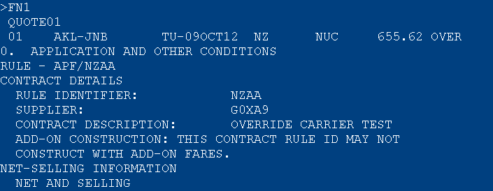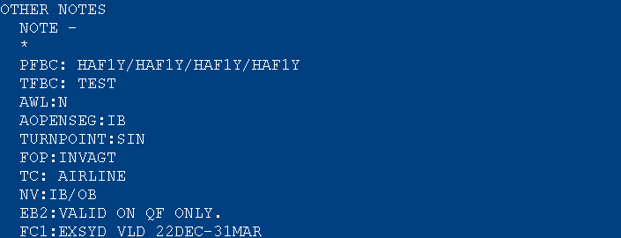

Eg. The script will use the value in the PFBC field to quote the published fare. The host entry for the above is FQS1@HAF1Y.2@HAF1Y.3@HAF1Y.4@HAF1Y. It then looks for a value in the TFBC field and in this case it will replace HAF1Y with the fare basis TEST.

|  |  |  |
| --- | --- | --- |
| Accessing the APF Script An active PNR must be open on your screen before you access the APF Script. The script will use the names and flights from this PNR when creating the fare.   * Retrieve PNR * Click on the APF Script Icon from the toolbar     The APF Script is displayed on 1 screen with different TABs.   * **Name Tab** - allows you to select passengers for the quote * **Flight Tab** - allows you to select modifiers for the quote * **Quote and Confirm Tab** - allows you to make amendments if required   The Title Bar shows the version of the APF Script, and just below this the Record Locator is displayed, which will be reflected throughout all windows in the script.    At the bottom of the screen is the “Actions” window which shows the host entry that the script is performing. Also found at the bottom is the traffic light indicator.    - Indicates the script is actioning a request  - Indicates the script is waiting for instructions Navigation within the Script You can navigate around the script using F keys or by using the mouse. The available options are shown at the bottom of the page above the actions window. |  |  |

# Screen 1 – Name Tab

This allows you to select passengers for the quote.

By default all names in the PNR are displayed, as ADULTS, regardless of the PTC filed in the PNR.

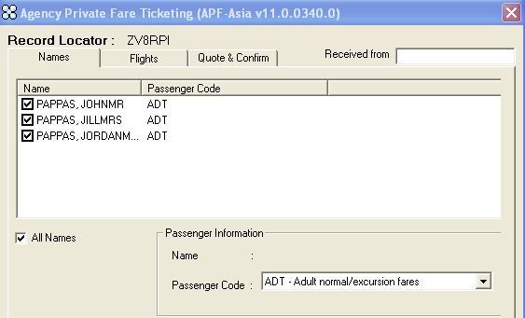

This can be updated by clicking in the box next to the name to deselect the passenger you do not want to change.

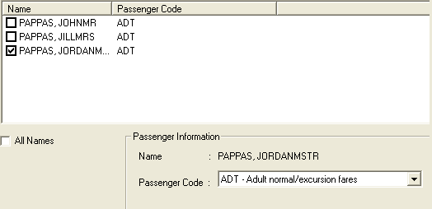

Then then using the drop down menu you would select a different passenger type.

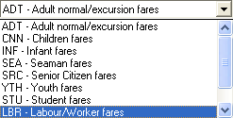

If you select a child fare, an additional age box will need to completed. Once you click out of the field the passenger type code will be updated.

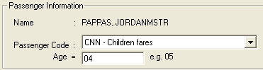 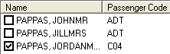

Then once you have updated your passenger type and selected the passengers you wish to quote you can click on the next TAB – Flights.

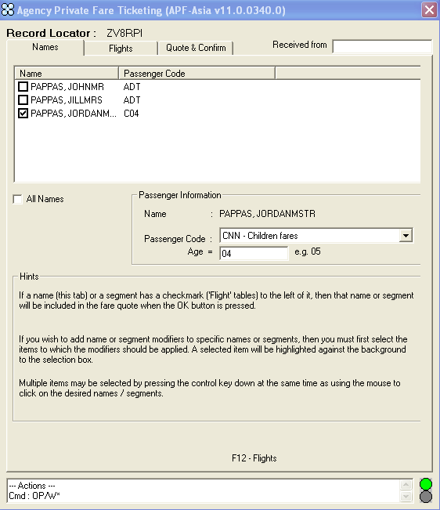

Please Note: Multiple passenger types can be quoted

# Screen 2 – Flight TAB

The agent needs to update the “APF – Airline & Account Code box only” and then press NEXT.

* **Airline** – Is generated from the PNR
* **Account Code** – Needs to be added by the agent if one applies
* **Segments** – Can be added for specific segments or left blank for all segments to be quoted

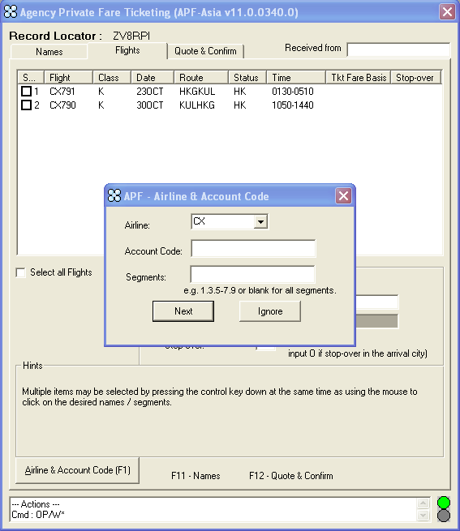

Once you have added the required information click “Next”. The script then returns confirmation the fare has been accepted.

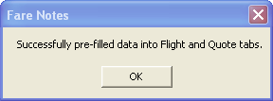

The flight screen is redisplayed with the Ticket Fare Basis values pre-populated from the TFBC field of the Agency Private Fares contact, under OTHER NOTES.

The agent then clicks on the Quote & Confirm TAB

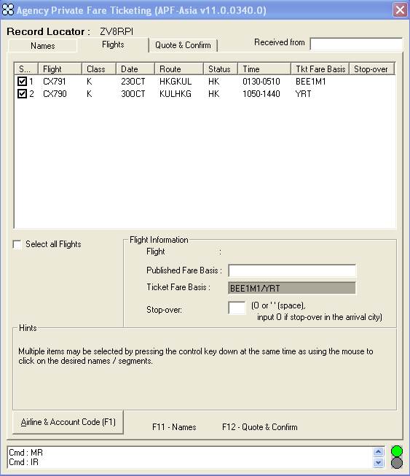

If the agent wants to re-quote they can click on Airline & Account Code or use the F1 button to retrieve the airline pop-up box.

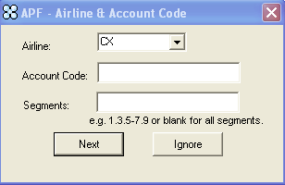

# Screen 3 – Quote and Confirm TAB

This screen is used to amend/add pricing modifiers if required. The agent does not need to update any fields on this screen unless they wish to over ride the data which was pre populated by the script.

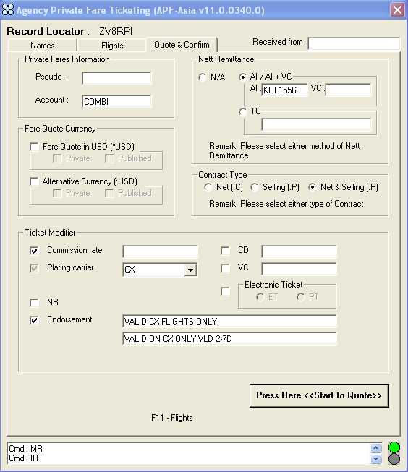

Once the modifiers have been selected you click “Press Here <<Start to Quote>> to move on.

**Fare Quote & Ticket Modifiers**

**Private Fares Information** allows you to add an alternative PCC or add / remove an account code.

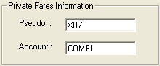

Host Entry: FQP1.2/CCX-**COMBI**\***XB7**:P/S1.2

**Fare Quote Currency** allows you to change either the private or published fare quote to USD.

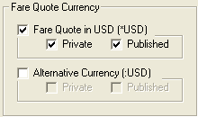

Host Entries: FQP1.2/CCX-COMBI:P/S1.2/**\*USD** – Private Fare Quote

FQP1.2/CCX:N/S1@BEE1M1.2@YRT/**\*USD** – Published Fare Quote

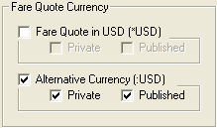

Host Entries: FQP1.2/CCX-COMBI:P/S1.2/**:USD** – Private Fare Quote

FQP1.2/CCX:N/S1@BEE1M1.2@YRT/**:USD** – Published Fare Quote

**Nett Remittance** allows you to update/amend the tour code/car code or value code, if required.

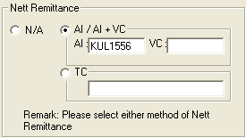 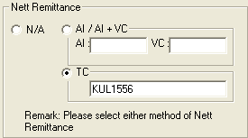

Host Entries: TMU1**AI**-KUL1556 TMU1**TC**KUL1556

**Contract Type** allows the agent to update/amend the contract type, if required

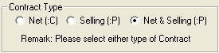 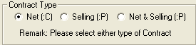

Host Entries: FQP1.2/CCX-COMBI**:P**/S1.2 FQP1.2/CCX-COMBI**:C**/S1.2

**Ticket Modifier** allows the agent to update/amend the various fields.

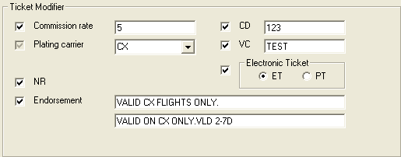

Host Entry: TMU2FINVAGT/**Z**5/NFAUD198.00/**NR**/**CD**-123/**VC-**TEST/**ET**

Host Entry: **FBUEB**/VALID CX FLIGHTS ONLY.VALID ON CX ONLY.VLD 2-7D

Once the modifiers have been selected you click “Press Here <<Start to Quote>>. The Private fare is then quoted and displayed on screen for each passenger.

### Agency Private Fare Confirmation

This screen displays the private fare quote for all passengers. To view all quotes the agent can use the scroll bar.

The agent then clicks **Next>>**

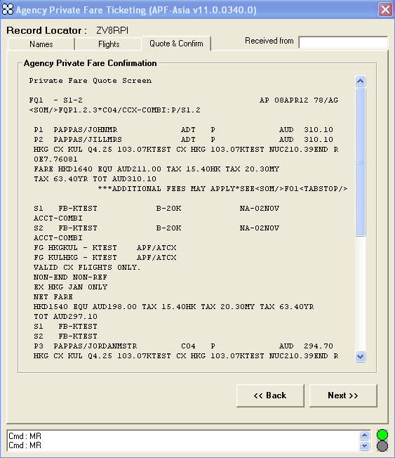

* This is the Agency Private Fare quote

### Net Fare Data

This screen shows the Private & Net fare for each passenger. It also allows agents to add an actual selling fare or Invoice if required.

The agent then clicks **Next>>**

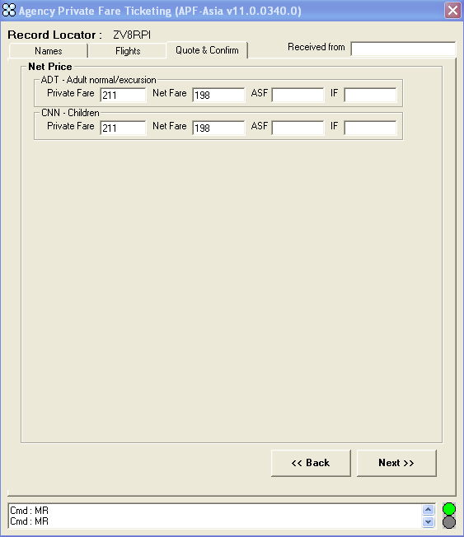

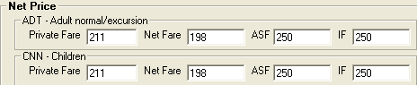

Host Entries: TMU1FINVAGT/NFAUD198.00/**ASF**250/**IF**250

### Payment Screen

This screen allows the agent to update/amend the form of payment. It also displays the data filed in the FC1-FC3 fields of the Agency Private Fares contract, under OTHER NOTES.

The agent then clicks **Next>>**

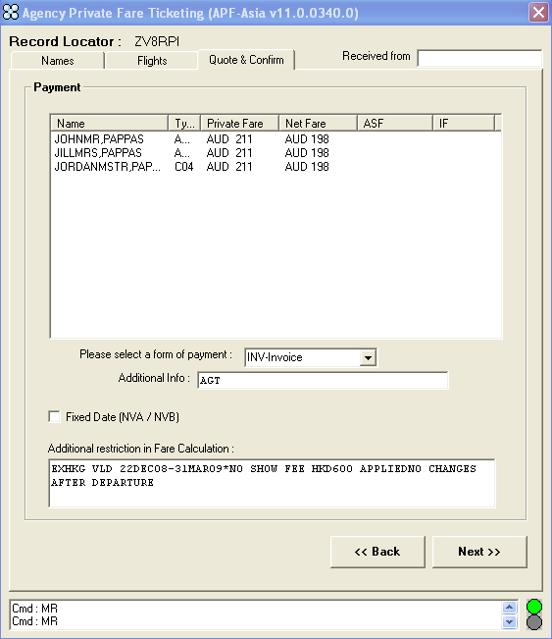

If the agent selects Fixed Dates, then the script will apply the travel dates

### Confirmation Screen

This screen displays both the published and private fare quotes for all passengers. To view all quotes the agent can use the scroll bar.

The agent then clicks <**Confirm>**

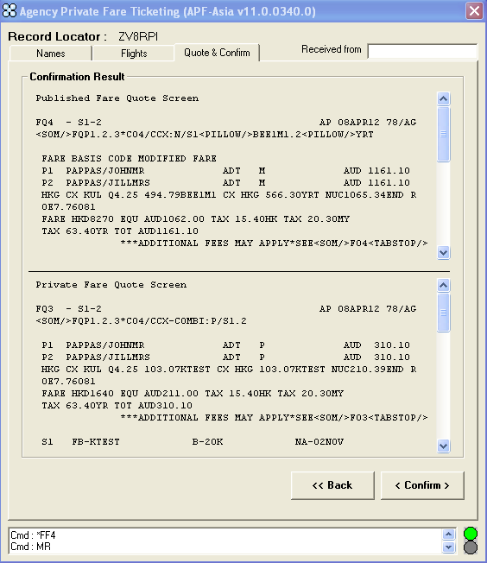

* The Published Fare Quote is taken from the PFBC field in the OTHER NOTES field of the contract.
* The Private Fare Quote is Agency Private Fare. .

The script then returns confirmation the fare has been accepted.

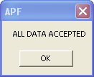

The agent is prompted to exit the script.

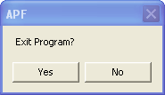

Yes - will end the script and return you back to the PNR

No - will return you to the Names TAB

# Example 1 – ADT & CHD Fare with a PFBC and TFBC

Step 1 – Retrieve the PNR

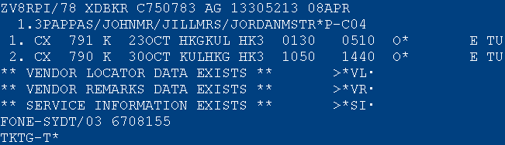

Step 2 – Click on the APF Script Icon 

Step 3 – Update the passenger code for the child

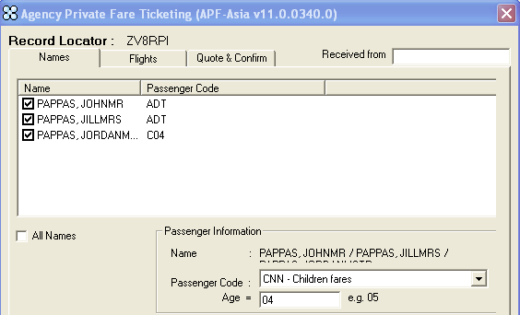

Step 4 – Click on the **FLIGHTS** tab

Step 5 – Complete the **“Airlines & Account Code”** Box

Step 6 – Click **NEXT**

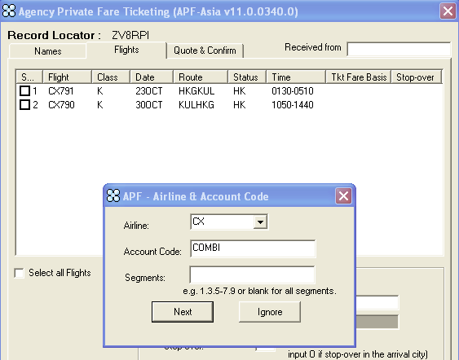

Step 7 – Click **OK**

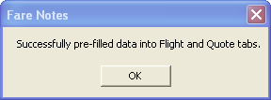

Step 8 – Click on the **Quote & Confirm** TAB

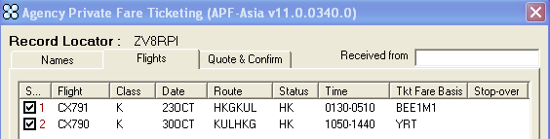

Step 9 – Complete Flight screen if required

Step 10 – Click **“Press Here <<Start to Quote>>**

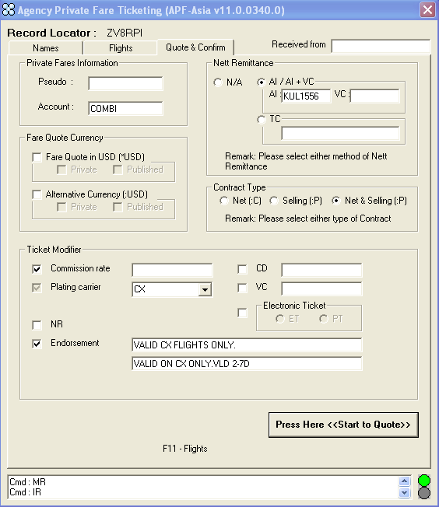

This screen shows the private fare quote.

Host Entry: FQP1.2.3*C04/CCX-COMBI:P/S1.2

Step 11 – Click **NEXT>>**

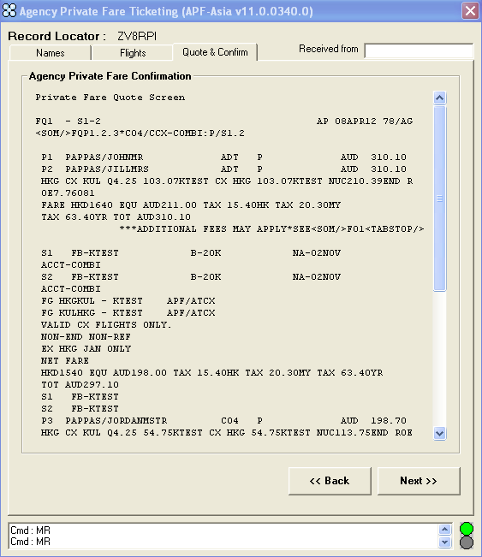

The Net Fare Data is displayed per passenger type.

Step 12 – Complete the ASF or IF fields if required

Step 13 – Click **NEXT>>**

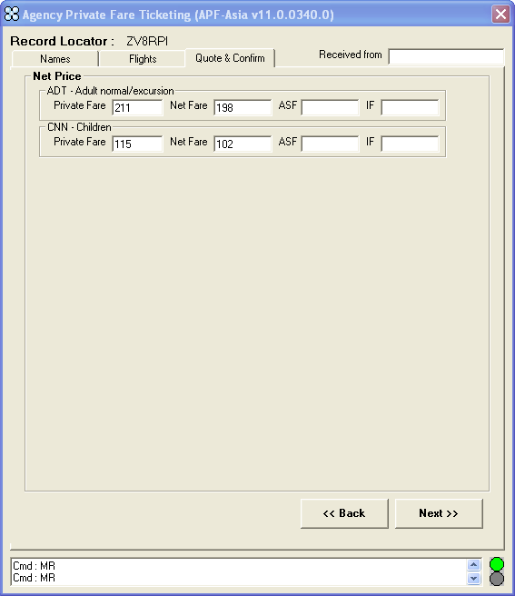

The Payment screen is displayed.

Step 14 – The agent can update form of payment, validity dates if required

Step 15 – Click on **Next>>**

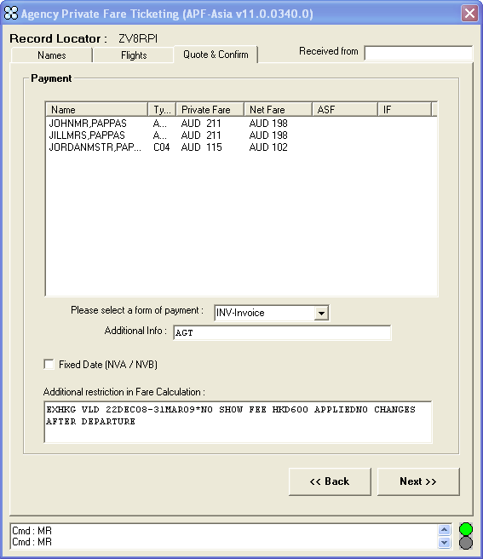

The published and private fare quotes are displayed on this screen.

Host Published Fare Entry: FQP1.2.3*C04/CCX:N/S1@BEE1M1.2@YRT

Host Private Fare Entry: FQP1.2.3*C04/CCX-COMBI:P/S1.2

Step 16 – Click **< Confirm >**

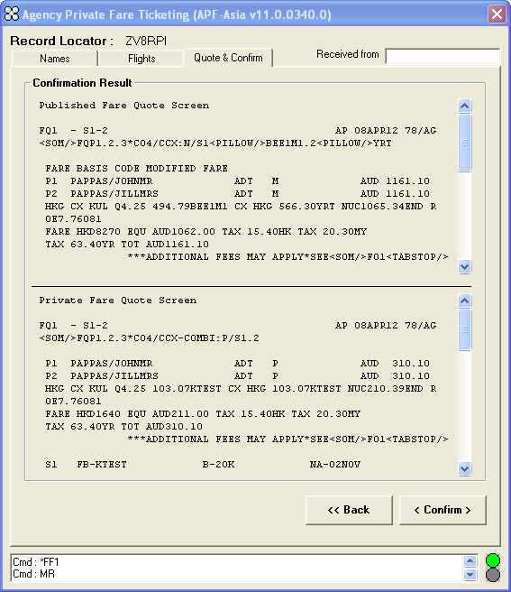

Step 17 – Click **OK**

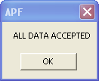

Step 18 – Click **Yes**

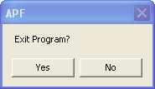

Step 19 – Redisplay the PNR - **\*R**

FQ1 - S1-2 AP 08APR12 78/AG

>FQP1.2/CCX-COMBI:P/S1.2

P1 PAPPAS/JOHNMR ADT B AUD 1161.10

P2 PAPPAS/JILLMRS ADT B AUD 1161.10

FQ1 - S1-2 AP 08APR12 78/AG

>FQP1.2/CCX-COMBI:P/S1.2

P1 PAPPAS/JOHNMR ADT B AUD 1161.10

P2 PAPPAS/JILLMRS ADT B AUD 1161.10

HKG CX KUL Q4.25 494.79**BEE1M1** CX HKG 566.30**YRT** NUC1065.34 EXHK

G VLD 22DEC08-31MAR09*NO SHOW FEE HKD600 APPLIEDNO CHANGES AFT

ER DEPARTURE END ROE7.76081

FARE HKD8270 EQU AUD1062.00 TAX 15.40HK TAX 20.30MY

TAX 63.40YR TOT AUD1161.10

***ADDITIONAL FEES MAY APPLY*SEE>FO1·

S1 FB-**BEE1M1** B-20K NA-02NOV

S2 FB-**YRT** B-20K NA-02NOV

VALID CX FLIGHTS ONLY.VALID ON CX ONLY.VLD 2-7D

NET FARE

HKD1540 EQU AUD198.00 TAX 15.40HK TAX 20.30MY TAX 63.40YR

TOT AUD297.10

T P01-02/S1-2/ET/FINVAGT/CCX/NFAUD198.00/AI-KUL1556

FQ2 - S1-2 AP 08APR12 78/AG

>FQP3*C04/CCX-COMBI:P/S1.2

P3 PAPPAS/JORDANMSTR C04 B AUD 882.70

FQ2 - S1-2 AP 08APR12 78/AG

>FQP3*C04/CCX-COMBI:P/S1.2

P3 PAPPAS/JORDANMSTR C04 B AUD 882.70

HKG CX KUL Q4.25 371.09**BEE1M1/CH25** CX HKG 425.21**YRT/CH25** NUC80

0.55 EXHKG VLD 22DEC08-31MAR09*NO SHOW FEE HKD600 APPLIEDNO CH

ANGES AFTER DEPARTURE END ROE7.76081

FARE HKD6220 EQU AUD799.00 TAX 20.30MY TAX 63.40YR

TOT AUD882.70

***ADDITIONAL FEES MAY APPLY*SEE>FO2·

S1 FB-**BEE1M1/CH25** B-20K NA-02NOV

S2 FB-**YRT/CH25** B-20K NA-02NOV

VALID CX FLIGHTS ONLY.VALID ON CX ONLY.VLD 2-7D

NET FARE

HKD790 EQU AUD102.00 TAX 20.30MY TAX 63.40YR TOT AUD185.70

T P03/S1-2/ET/FINVAGT/CCX/NFAUD102.00/AI-KUL1556

**Agency Private Fare**: KTEST

**PFBC**: BEE1M/YRT

**TFBC**: BEE1M/YRT

### 

# Example 2 – ADT and CNN Fare with PFBC only

Step 1 – Retrieve the PNR



Step 2 – Click on the APF Script Icon 

Step 3 – Update the passenger code for the child



Step 4 – Click on the **FLIGHTS** tab

Step 5 – Complete the **“Airlines & Account Code”** Box

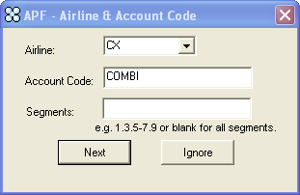

Step 6 – Click **NEXT**

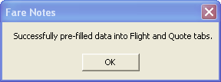

Step 7 – Click **OK**



Step 8 – Click on the **Quote & Confirm** TAB



Step 9 – Complete Flight screen if required

Step 10 – Click **“Press Here <<Start to Quote>>**

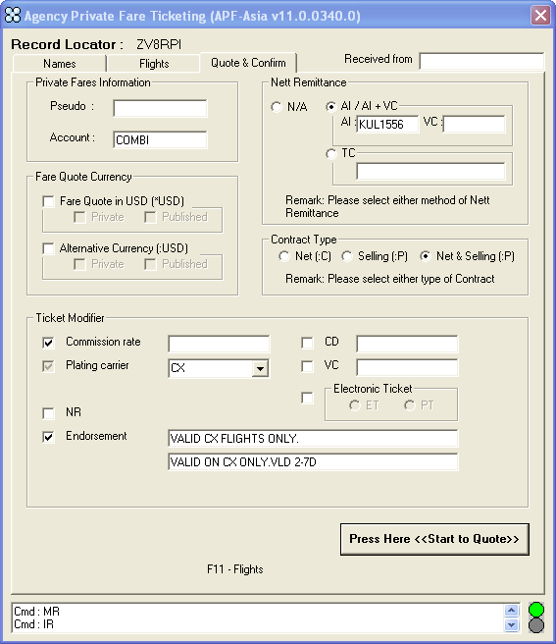

This screen shows the private fare quote.

Host Entry: FQP1.2.3*C04/CCX-COMBI:P/S1.2

Step 11 – Click **NEXT>>**

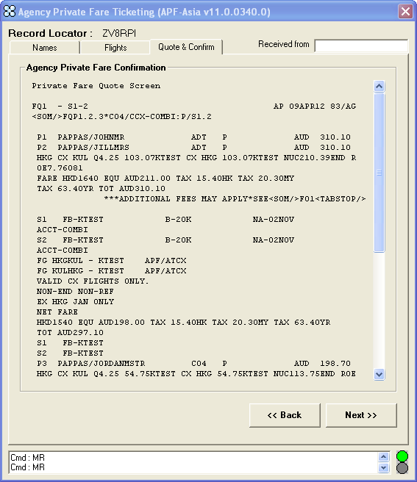

The Net Fare Data is displayed per passenger type.

Step 12 – Complete the ASF or IF fields if required

Step 13 – Click **NEXT>>**



The Payment screen is displayed.

Step 14 – The agent can update form of payment, validity dates if required

Step 15 – Click on **Next>>**



The published and private fare quotes are displayed on this screen.

Host Published Fare Entry: FQP1.2.3*C04/CCX:N/S1@BEE1M1.2@YRT

Host Private Fare Entry: FQP1.2.3*C04/CCX-COMBI:P/S1.2

Step 16 – Click **< Confirm >**



Step 17 – Click **OK**



Step 18 – Click **Yes**



Step 19 – Redisplay the PNR - **\*R**

FQ1 - S1-2 AP 08APR12 78/AG

>FQP1.2/CCX-COMBI:P/S1.2

P1 PAPPAS/JOHNMR ADT B AUD 1161.10

P2 PAPPAS/JILLMRS ADT B AUD 1161.10

FQ1 - S1-2 AP 09APR12 83/AG

>FQP1.2/CCX-COMBI:P/S1.2

P1 PAPPAS/JOHNMR ADT B AUD 1161.10

P2 PAPPAS/JILLMRS ADT B AUD 1161.10

HKG CX KUL Q4.25 494.79**KTEST** CX HKG 566.30**KTEST** NUC1065.34 EXH

KG VLD 22DEC08-31MAR09*NO SHOW FEE HKD600 APPLIEDNO CHANGES AF

TER DEPARTURE END ROE7.76081

FARE HKD8270 EQU AUD1062.00 TAX 15.40HK TAX 20.30MY

TAX 63.40YR TOT AUD1161.10

***ADDITIONAL FEES MAY APPLY*SEE>FO1·

S1 FB-**KTEST** B-20K NA-02NOV

S2 FB-**KTEST**  B-20K NA-02NOV

VALID CX FLIGHTS ONLY.VALID ON CX ONLY.VLD 2-7D

NET FARE

HKD1540 EQU AUD198.00 TAX 15.40HK TAX 20.30MY TAX 63.40YR

TOT AUD297.10

T P01-02/S1-2/ET/FINVAGT/CCX/NFAUD198.00/AI-KUL1556

FQ2 - S1-2 AP 08APR12 78/AG

>FQP3*C04/CCX-COMBI:P/S1.2

P3 PAPPAS/JORDANMSTR C04 B AUD 882.70

FQ2 - S1-2 AP 09APR12 83/AG

>FQP3*C04/CCX-COMBI:P/S1.2

P3 PAPPAS/JORDANMSTR C04 B AUD 882.70

HKG CX KUL Q4.25 371.09**KTEST** CX HKG 425.21**KTEST** NUC800.55 EXHK

G VLD 22DEC08-31MAR09*NO SHOW FEE HKD600 APPLIEDNO CHANGES AFT

ER DEPARTURE END ROE7.76081

FARE HKD6220 EQU AUD799.00 TAX 20.30MY TAX 63.40YR

TOT AUD882.70

***ADDITIONAL FEES MAY APPLY*SEE>FO2·

S1 FB-**KTEST** B-20K NA-02NOV

S2 FB-**KTEST** B-20K NA-02NOV

VALID CX FLIGHTS ONLY.VALID ON CX ONLY.VLD 2-7D

NET FARE

HKD790 EQU AUD102.00 TAX 20.30MY TAX 63.40YR TOT AUD185.70

T P03/S1-2/ET/FINVAGT/CCX/NFAUD102.00/AI-KUL1556

**Agency Private Fare**: KTEST

**PFBC**: BEE1M

**TFBC**: